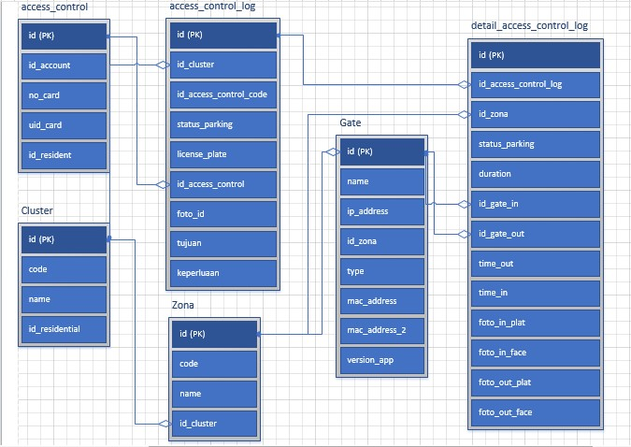
Perhatikan gambar diatas, table zona memiliki foreign key di table gate, table gate memiliki foreign key di table detail_access_control_log, logikanya table detail_access_control_log bisa mendapatkan data dari table zona dengan cara join gate, join zona tapi justru di table detail_access_control_log dituliskan id_zona yang langsung me refer ke table zona sehingga terjadi error seperti dibawah ini

Introducing FOREIGN KEY constraint 'FK_Detail_access_control_log_Zona_id_zona' on table 'Detail_access_control_log' may cause cycles or multiple cascade paths. Specify ON DELETE NO ACTION or ON UPDATE NO ACTION, or modify other FOREIGN KEY constraints.
Could not create constraint or index. See previous errors.
Solusi :

1. Model Zona.cs tambahkan kode berikut :

//ini artinya id zona dipakai sebagai foreign key di table Detail_access_control_log
public virtual ICollection<Detail_access_control_log> Detail_access_control_logs { get; set; }

2. VDI.Demo.EntityFrameworkCore\EntityFrameworkCore\DemoDbContext.cs

Tambahkan kode warna hijau :

protected override void OnModelCreating(ModelBuilder modelBuilder){
...
modelBuilder.Entity<Detail_access_control_log>() // 1 Detail_access_control_log
.HasOne(u => u.Zona) // memiliki 1 zona
.WithMany(u => u.Detail_access_control_logs) //1 zona memiliki banyak Detail_access_control_log
.OnDelete(DeleteBehavior.Restrict); // Detail_access_control_logs (hijau tebal)
// diambil dari zona.cs (poin no 1)

modelBuilder.ConfigurePersistedGrantEntity();
...
}

